draft: work in progress

[Student app - Basic Exercises experience]

functional specification

# Executive Summary

## Background

The whole Parrot suit aims to provide a new mobile experience to AF students to perform exercises off class. Parrot suit is composed of 3 roles:

* Teachers (mobile app)
  + Prepare and give courses at class
  + Assign exercises to students off class thru email/Baidu Yun
  + Correct answers sent from students thru email.
* Students (mobile app)
  + Learn French at class
  + Conduct exercises assigned by teacher
* Institute (PC)
  + Manage classes
  + Manage teachers
  + Manage students (enrollment, notification, etc.)
  + Assign teachers and students to classes

This spec is focused on Basic exercises scenarios for student app.

An exercise is composed of sections. A section is composed of Problem, and a problem has several quizzes.

Exercise: 31 je mange de la salade (我吃蔬菜）

Section: 1

Problem：a. Associer les nationalites et les aliments en utilisant « le », « la », « les »

例子 (sample): 1. les italiens => ils aiments les pates => les mangent des pates

问题 (quiz)：2. les chinois

回答 (answer): 填空题

问题 (quiz): 3. les suisses

回答 (answer): 填空题

Problem: "b. Dites ce que vous aimez et ce que vous mangez"

回答 (answer): 填空题

Section: 2

Problem: Faites des phrases en utilisant des patitifs, selon le modele.

例子 (sample): 1. Boucher - chez le boucher, on achete de la viande

Quiz: 2. Boulanger

回答 (answer): 填空题

There are 4 types of quizzes:

* Single selection 单选题
* True/false 是非题
* Fillblank 填空题
* Multiple selection 多选题

# Functional Requirements (High-Level) for Pri1 scenarios

## General requirements for App

|  |  |  |  |  |
| --- | --- | --- | --- | --- |
| App Setting | | | | |
|  | Font setting (font and font size) |  | 3 | Can be Pri2 for elder teachers. |
|  | UI language (Chinese/French/English)   * By default: be aligned with Phone languages |  | 1 | M1: provide default setting  M2: allow users to customize |
|  | Background picture |  | 3 |  |
|  | Term of usage |  | 2 |  |
|  | Help and Feedbacks collection |  | 1 | M1 |
| **Installation (on Android only)** | | | | |
|  | Install on mobile phone at first time   * Default install on the phone. * Data storage based on phone setting |  | 1 | M1: default setting  M2/M3: allow users to choose where to install: phone or SD card |
|  | Move the app to SD card |  | 2 | Probably fine not to cover in M1. |
|  | Uninstall with data removal |  | 1 | M1 |
|  | Uninstall by keeping data |  | 2 |  |
|  | Reinstall with data kept |  | 2 |  |

## Teachers Pri1 Scenarios

## Teacher app will be replaced by Admin tool in M1. We will review this part in M2

|  |  |  |  |  |
| --- | --- | --- | --- | --- |
| # | Requirement | Metrics | Priority | Milestone |
| **Sign-up/Sign-in/sign-out** | | | | |
|  | Sign-in with Email registered at the institute. | # sign-in attempts  # success/failure | 1 | M1 |
|  | Sign-in with mobile phone # registered at the institute | # sign-in attempts  # success/failure | 1 | M2: probably sign-up with Email is OK for M1? |
|  | User sign-out. | # sign-out attempts  #success/failure | 1 | M1 |
|  | User sign-up with Email and create a new password | # sign-up attempts  # success/failure | 1 | M1 |
|  | User sign-up with mobile phone # and create a new password |  | 2 | M2? |
|  | User change password | # pwd changed  # success/failure | 1 | M1 |
| **Manage one exercise or one historical exam to a group** | | | | |
|  | Upload/modify/delete a selective exercise (选择题) | # exercises  # success/failure | 1 | M1 |
|  | Upload/modify/delete a Yes/No or Yes/No/I do not know exercise (对错题). There are 2 types of 对错题   * Yes or No * Yes or No or I do not know (when it’s not mentioned in the text) | # exercises  #success/failure | 1 | M1 |
|  | Upload/modify/delete a written exercise (写作题) | # exercises  #success/failure | 2 | M2 |
|  | Upload/modify/delete a matching exercise (配对题) | # exercises  #success/failure | 1 | M1 |
|  | Upload/delete/modify an exercise with an audio file 听力题 (mp3, wav)  (what are audio format and size limit to support?) | # exercises  # success/failure  audio file size uploaded  Audio file format uploaded | 1 | M1 |
|  | Upload/delete/modify an exercise with several pictures (jpg, png, jpeg)  (what are image format and size limit to support?) | # exercices  # success/failure  # image files | 1 | M1 |
| **Manage Group** | | | | |
|  | Create a group and auto-assign with a default name   * One group for exercises refers to a course level * One historical exam group refers to a specific year/date for that exam | # groups created | 1 | M1 |
|  | Validate group name if not exist |  | 1 | M1 |
|  | Check group name with restriction upon creation? Do we need to apply some name convention here? |  | 2 |  |
|  | Delete a group (exercises in the group will be deleted too)  (how about a group distributed? Or only allow to delete if not distribute? If yes, teacher needs to recall the group first) | # groups deleted | 2 |  |
|  | Delete several groups (how about groups distributed?) |  | 2 |  |
|  | Rename a group after its creation  (how about if a group is distributed to students already? Or this is only allowed when a group is not distributed?) | # groups renamed | 1 | M1 |
| **Distribute exercises to students** | | | | |
|  | Tag a group for distributed or not distributed |  | 1 | M1 |
|  | Select and Distribute an exercise from a group |  | 1 | M2:  Assume at the beginning teacher will rather bulk distribute exercises instead of distributing one single exercise |
|  | Select and Distribute several exercises from a group |  | 1 | M1 |
|  | Select and Distribute one group |  | 1 | M1 |
|  | Select and Distribute several groups |  | 2 | M2/M3? |
| **Report – students/exercises/time** | | | | |
|  | Print out report |  | 3 |  |
|  | Teacher can see # of exercises completed by students given a time frame |  | 1 | M2 |
|  | Show summary report (with Pie format) |  | 1 | M1 |
|  | Select one section in Pie and break down into a detailed report |  | 1 | M1 |

## Students Pri1 scenarios

|  |  |  |  |  |
| --- | --- | --- | --- | --- |
| # | Requirement | Metrics | Priority | Milestone |
| **Sign-up/Sign-in/sign-out** | | | | |
|  | Sign-in with Email (not everyone provides email upon registration) | # sign-in attempts  # success/failure | 2 | M2 |
|  | Sign-in with mobile phone | # sign-in attempts  # success/failure | 1 | M1 |
|  | User sign-out | # attempts  #success/failure | 1 | M1 |
|  | User sign-up with email, license code and set a new password | # attempts  # success/failure | 2 | M2 |
|  | User sign-up with mobile phone # and create a new password |  | 1 | M1 |
|  | User change password | # attempts  # success/failure | 1 | M1 |
| **Conduct exercises and historical exams** | | | | |
|  | Answer a selective exercise (选择题) | # exercises  # success/failure | 1 | M1 |
|  | Answer a Yes/No exercise (对错题) | # exercises  #success/failure | 1 | M1 |
|  | Answer a written exercise (写作题) | # exercises  #success/failure | 2 | M3 |
|  | Answer a matching exercise (配对题) | # exercises  #success/failure | 2 | M2 |
|  | Upload audio file to an exercise听力题 (mp3, wav)  (what are audio format and size limit to support?) | # exercises  # success/failure  audio file size?  Audio file format? | 1 | M1 |
|  | Upload pictures to an exercise (jpg, png, jpeg)  (what are image format and size limit to support?) | # exercices  #success/failure  # image files | 1 | M1 |
| **Show exercise group and historical exams** | | | | |
|  | List of exercises and exams (what is default view: by course level) |  | 1 | M1 |
|  | View by sorting groups with date of publishing | # view selected | 2 | M3 |
|  | View by sorting groups with completion status | # view selected | 2 | M2 |
|  | View by sorting groups with course level followed with years of exams | # view selected | 1 | M1 |
|  | From group list view, each group shows # completed / # total |  | 1 | M1 |
|  | From one group view, show # completed, # correct, # wrong |  | 1 | M1 |
|  | From one group view, show list of exercise groups so students can jump to quickly??? |  | 2 | M3 |
|  | From one group view, show an arrow to enter into next exercise level |  | 1 | M1 |
|  | From one group view, show an arrow to enter into previous exercise level |  | 2 | M2 |
|  | From one group view, show an arrow to be back to group list overview. |  | 1 | M1 |
|  | Hide/Unhide a group |  | 2 | M3 |
|  | Delete a group (maybe needed due to storage size on local devices???) |  | 2 | M3 |
| **Notification experience** | | | | |
|  | Show new exercises # distributed on App icon |  | 1 | M1 |
|  | Show new exercises # distributed information at Notification center |  | 1 | M1 |
|  | Click notification message will launch the app |  | 1 | M1 |
|  | Turn on/turn off the notification   * Turn on by default |  | 2 | M1: turn on by default  M2: allow to turn off. |

# Detailed

## Students first experience with Parrot app

For a student to sign in the app, he will need an access code and a default password. Prior to this, teacher or admin will generate the code thru Admin tool. One code will be assigned to one class given one semester. At the end of the semester, the code will expire. For a new semester, teacher can require a new access code with the admin tool.

When a student signs up, he needs to provide his name which will be displayed at the app. Password needs to be changed too at first usage of the app too.

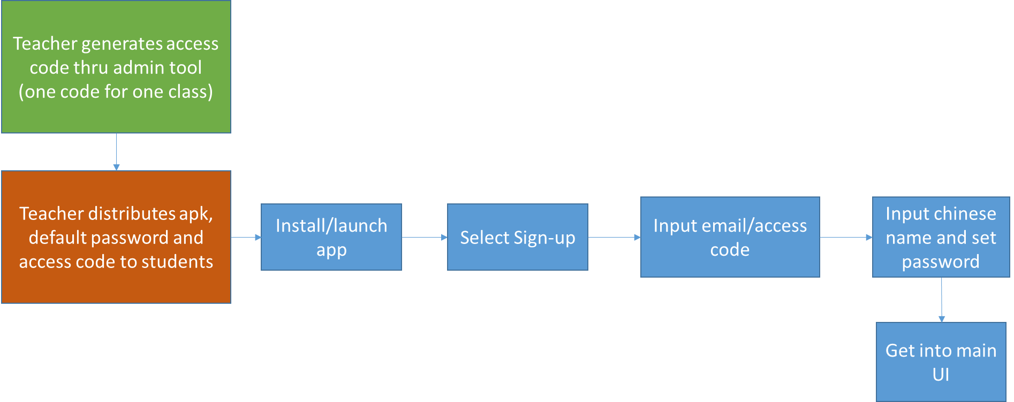

## Student second sign-in flow is as blow.

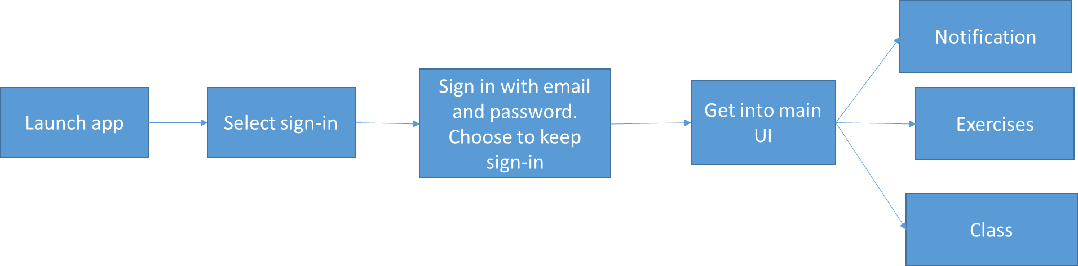

## Exercises general flow

Student can pause or exit the app and resume exercises. Student can restart doing exercises from the beginning and his score will be updated accordingly. Before final submission, students can move back to previous exercises to correct his answers. After students submit his answers, teacher will be able to view it from his side and generate statistic reports for his class in M1. In M2, we will design interaction between teachers and students for exercises thru the app.

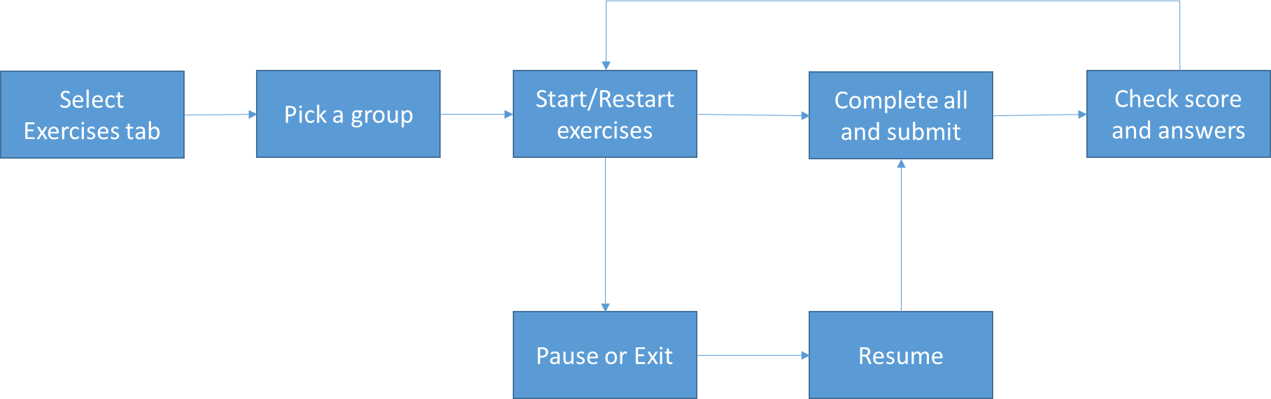

## Notification flow

Open issue: do we allow students to save messages as favorite (e.g. msg regarding exams). Do we allow students to delete msg ?

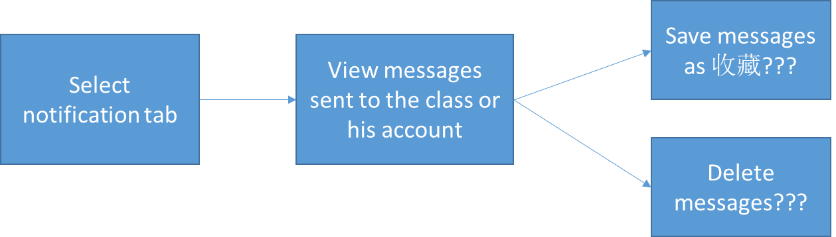

## Class flow

M1 students can only view teacher and list of students in a class.



# Success Measurements & Instrumentation

## General Success Metrics

NOTE: Most of these metrics should be seen **Exercises** goals while during M1 we potentially have two Apps in parallel which might skew some of the success metrics.

|  |  |  |  |  |  |
| --- | --- | --- | --- | --- | --- |
| Scenario: General Basic exercises metrics | | | | | |
| Question | **Usage Plan** | | **Pri** | **Metric (s)** | **Success metric (s)** |
| Measuring Launching  Do first time users install and open the app? | If we do not meet the installation metrics we need to improve the way we promote the app to the users for its benefits. | | 1 | * How many installation of the app? * How many times was the app opened per user? * From the first time the app was opened, how long did it take for a user to start doing exercises * The first time from when they open the app to the next time they open | Quantitative Success metric:   * Phone/tablet:   + during first week, **50%** users install and open at least once   + during first month, **80%** users install and open at least once * Average time from the first time from when they open the app to next time they open it is **less than a week**   Qualitative Success metric:   * **70%** of users think the app is helpful for their study. |
| Measuring Adoption  Do first time users start to perform exercises after they open the app?  How many students don’t perform exercises at first experience? | We expect students to start performing exercises at first time when launching the Parrot app.  If we do not see the usage pattern to be leaning towards 1st experience we'll rethink the experience or content delivered | | 1 | * #/% of users start exercises at 1st launching * #/% of users start exercises after 1st launching (Do users continue to do exercises after 1st experience?) * #/% of exercises completed per user * #/% users completed per exercise (Is exercise format easy for students to understand and execute?) | Quantitative Success metric:   * **80%** users start exercises after opening the app * **50%** users complete all exercises after one month? * Overall # exercises completed **increased** over time |
| Measuring Reliability  Do our users successfully complete/submit exercises without error or crash? | We expect users to feel empowered to do bunch of exercises through the end without hitting error. If user gets error or the app crash more often, we need to revisit why that is. If people do not successfully submit, we need to revisit robustness. | | 1 | * % of Successful exercises by returning OK * % of exercises encountered error or app crash when submitting or inputting. (any constraint on Phone device, e.g. memory limit?) | Quantitative Success metric:   * **90%** success rate when doing exercises without error/crash |
| Measuring Performance  Do users feel answering exercises from the app is fast and fluid? | We expect users to feel fluid when conducting exercises one by one. If people take more time to submit or pass to next exercise, we will revisit the experience | | 1 | * Average time taken to complete an exercise per type | Qualitative Success metric:   * we get +4 (out of 5) on the perceived perf rate assessed via user feedback   Quantitative Success metric:   * Avg. time taken to submit an exercise is < than X seconds (Need to look at 智商小测试data shared at Wechat for example to come up with a number here) * Time taken to complete/submit an exercise is equal to or lesser than 小测试 at Wechat (?) |
| Measuring Usability  Do users like the experience of conducting exercises using our app? | | Tweak the design for the share workflow and get more user feedback from flighting and A/B testing. Iterate this process till we achieve our success metrics | 1 | # of users follow the designed flow to complete exercises (to submit, to pass to next, to exit, etc.)  # of exercises not done by a user | Qualitative Success metric:  For the exercises feature, we get +4 (out of 5) positive appeal rate assessed via user feedback  80% users find the design is intuitive via user feedback.  Quantitative Success metric:   * <20 % exercises are not done by the user. |

# Telemetry & Test in Production

[Guidelines](https://microsoft.sharepoint.com/teams/osg_threshold_specs/SitePages/Telemetry.aspx)

## Telemetry

## Test in Production

# Risks & Open Issues

[Guidelines](http://portals/wpblue/blue/teams/rm/Pages/Risks_OpenIssues.aspx)

## Risks

## Open Issues

# DOCUMENT UPDATE HISTORY

|  |  |  |
| --- | --- | --- |
| Date | Author | Changes |
| 8/15/2014 | Fei Wu | First Draft of one pager |
| 8/30/2014 | Fei Wu | Initial Review of scenarios, goals and non-goals complete |
| 9/22/2014 | Fei Wu | High level requirement review complete |
| 9/10/2014 | Fei Wu | Add general metrics |

appendix

# Definitions & Acronyms

# References

# Feature Q&A / Decisions

# Appendix (Deleted content that may be of use later)

## High-level schedule

Each semester lasts for 19 weeks not including holiday. Our release will be based on AF semester schedule. M1 (milestone 1) refers to the semester September 22th 2014 – Feb. 1st 2015. M2 refers to the semester from Feb. – May 2015. M3 refers to the semester May – August 2015.

For M1 schedule

* Oct. 1st: self-host build ready for internal testing purpose.
* Oct. 1st – Oct. 15th: 1) self-hosting with internal participants. 2) Metric data auto-collection coding, 3) Feedback collection tool coding so that students/teachers can report issues directly from their phones.
* Oct. 31st : beta release with Feedback collection tool
* Nov. 1st – Feb. 1st: beta release for AF A1.1 students and teacher. (can we roll out App update whenever we wish to fix important bugs for example. )
* First week of January: survey with students and teacher.

How can we triage and track issues reported from students/teachers. Is there an existing 3rd party open source tool?